

LINUX PRACTICAL TEST REVISION

Name:  Zara Teo Xiao Xuan | Admin No.  194123U | Group:  CS1902 | Seat/PC No. 21

INSTRUCTION:

- Write your name, admin number and group in above boxes.
- If you need to create any files or folders, create them in the server’s (VM) C:\ drive unless the question states otherwise. Do not create them anywhere else.
- You must copy the screen output and paste it into the text box for marking. You can use the snipping or other tool to do this.
- All tasks are performed on the Linux Server. If the Linux Client need to be accessed, it shall be stated.
- If the question states to use CLI (Command Line Interface), you must use the terminal mode as shown below.
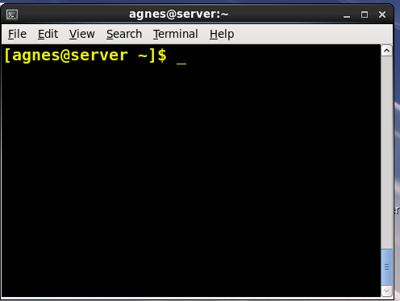
- Directory listing is in long format unless otherwise stated.

Tasks:

- Add a hard disk to the Linux Server of 10 GB. Configure it into 2 partitions of about 5 GB each and mount them as Sales and Finance

[Practical 8C]

Use disk utility to show your disk configuration.

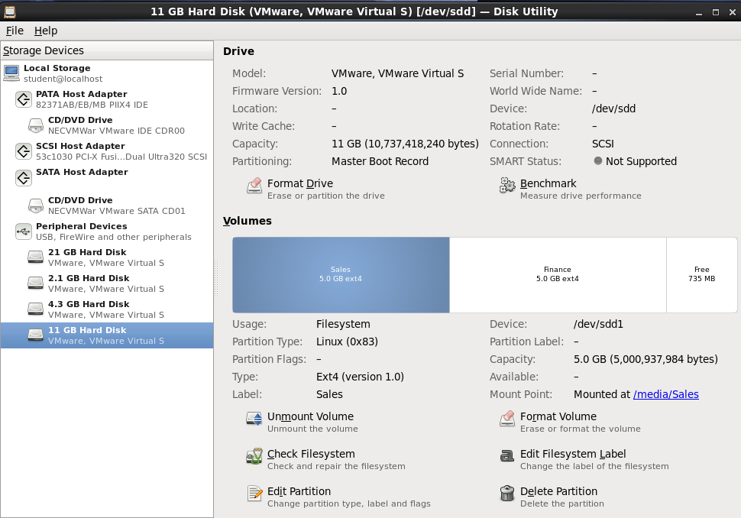
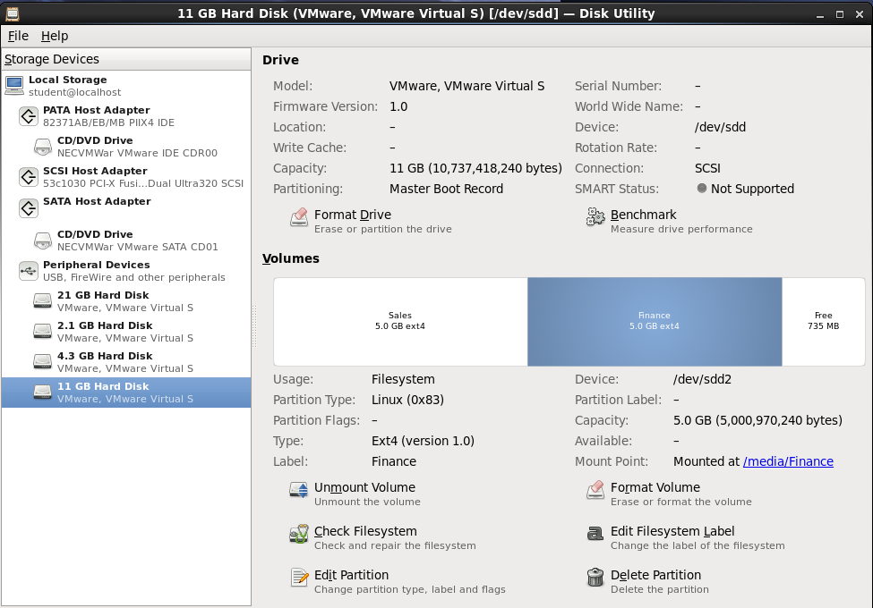

- Configure the server network settings as follows:
IP4 address = 10.0.0.5
Network mask = 8 or 255.0.0.0
DNS = 10.0.0.5

[Practical 8B]

Use the graphical interface to display the network settings (ie. NOT using ifconfig).

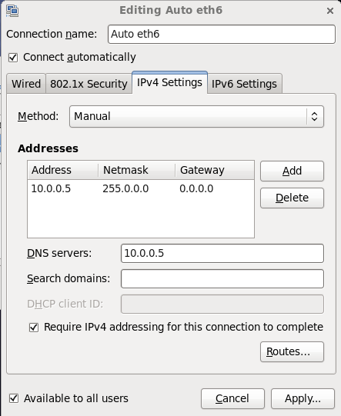

3. Create 2 users - agnes and sally with same password “redhat”. You can use any method for this.

[Practical 9C]

Use CLI to display output screen to show the users and their password have been created.
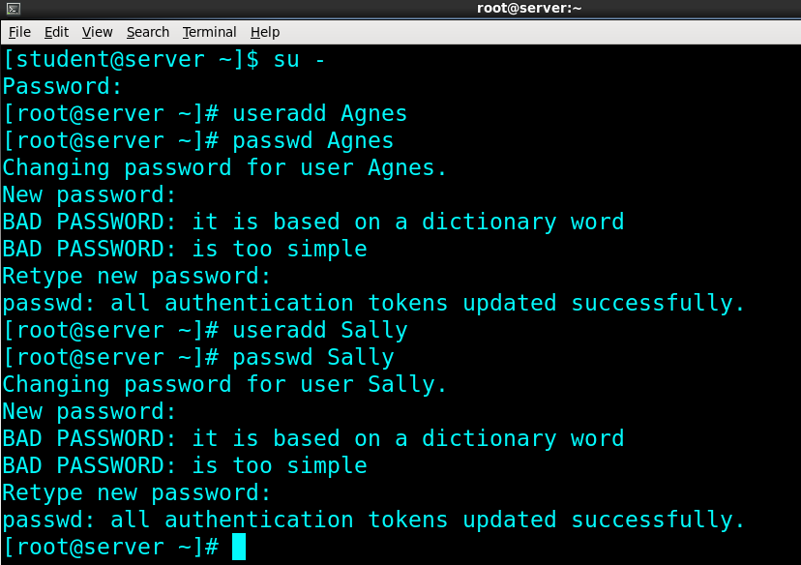
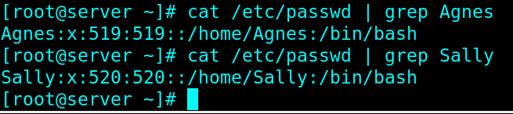
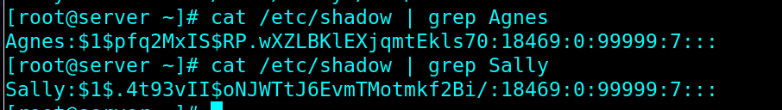

4. Create a group named “admingroup” and add agnes and sally as its members. You can use any method to do this.

[Practical 9C]

Use CLI and display the command and output screen to show the group is created with agnes and sally as its members.
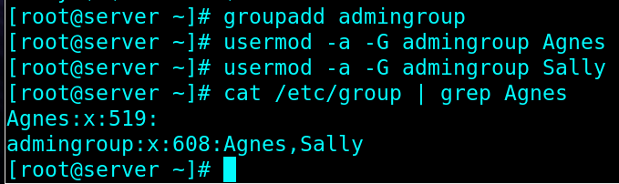

5. Switch to agnes account. Change to agnes home directory and list the contents including hidden ones.

[Practical 9A]

Use CLI to display current location and list the directory (including hidden items). Display the commands and output here.
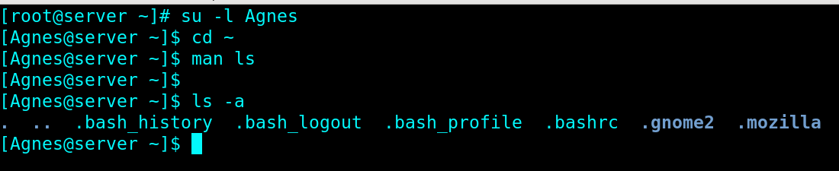

6. Make a sub directory named “salesreport” inside /home/agnes directory. You can use any method to do this. Change the salesreport permission such that “others” has no permission at all. Display the directory and its permissions.

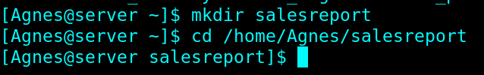
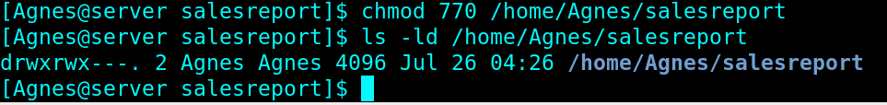

7. Change the salesreport group owner to admingroup. Change the permission of the group owner of salesreport to Read and Execute only. Display the salesreport permissions using CLI.

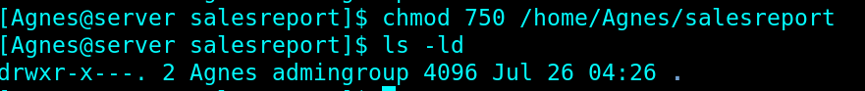

8. While logged in the server as agnes, create 3 files in /home/agnes directory. Name the files as jan.txt feb.txt mar.txt. They can be empty or non-empty. You can use any method to do this.

Display /home/agnes directory to show the 3 files in long listing format.
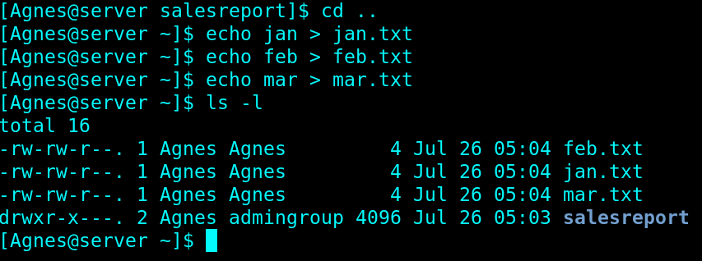

9. Create a directory /home/reports and make it shareable to the admingroup. Admingroup members have Read & Write & Execute permissions but cannot delete others files. Others have no access at all. Display the /home/reports permission after configuration.

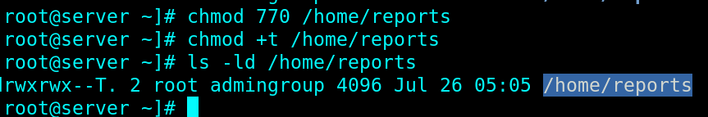

10. Switch to agnes and sally accounts and create some files in the /home/reports directory. Issue the command “ls -la /home/reports” and paste the command and output below as proof.

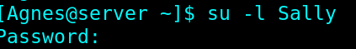
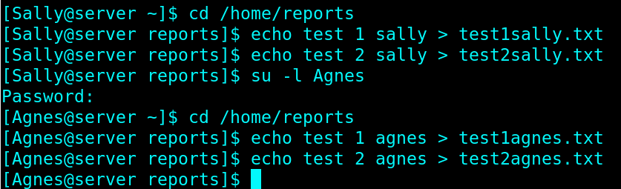
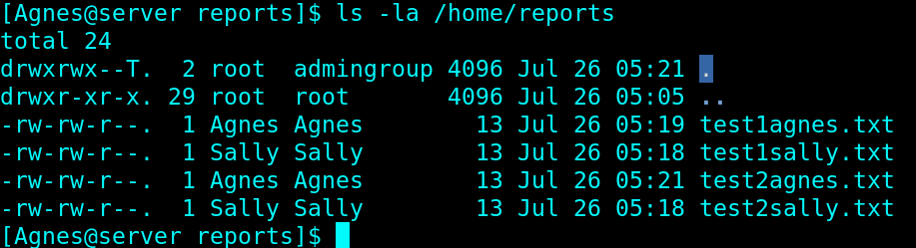

11. Create another user mike and show that he cannot access the /home/reports directory. Display your proof below.

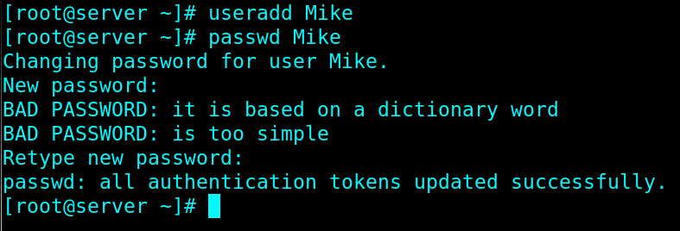
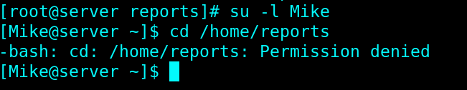

12. Use ACL to enable mike to have Read access only to /home/reports directory. Display the ACL permissions after configuration.

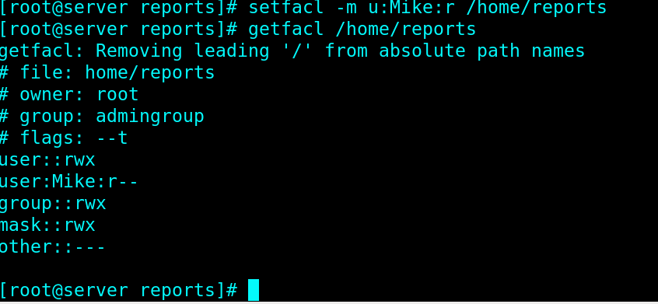

13. Use tar command to backup /etc directory to /var directory. The backup file name is backup.tar. Display the command and the backup file.

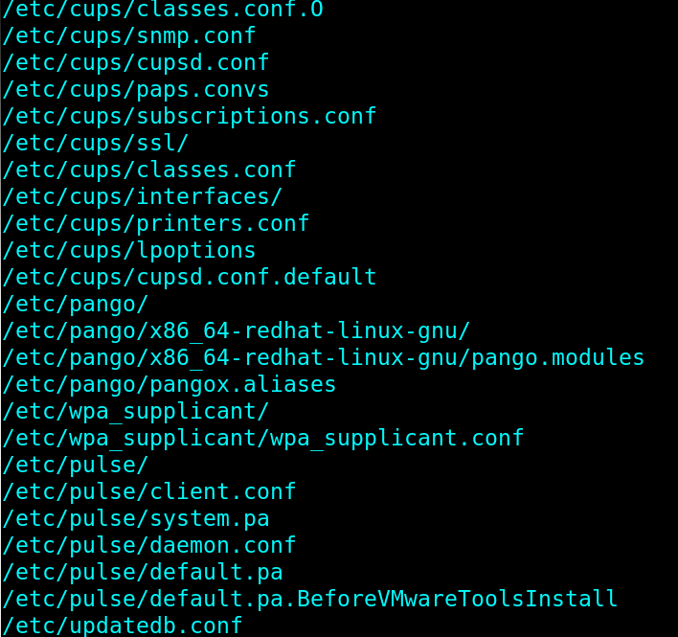

- End of Paper -

